**Market Basket Matrix**

Connect to sample superstore data and create a join with another orders data source using Order_id = Order_id and Sub_category<> Sub_category as a join condition.

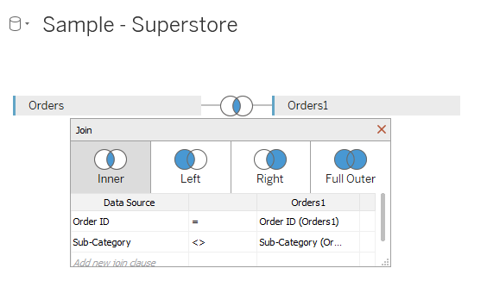

Go to the work sheet and Drag Sub_category to the columns shelf and Sub_category(orders1) to the rows shelf.

Drag Order_id to the text shelf and change the measure to count(distinct)

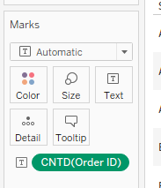

Control click on the (Order_ID) on the text shelf and drag drop it to the colors shelf.

Change the Marks to square.

The chart will have same numbers on both sides.

Go to the data source and change the Sub_category join condition to <=

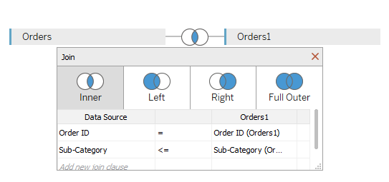

The output will look like

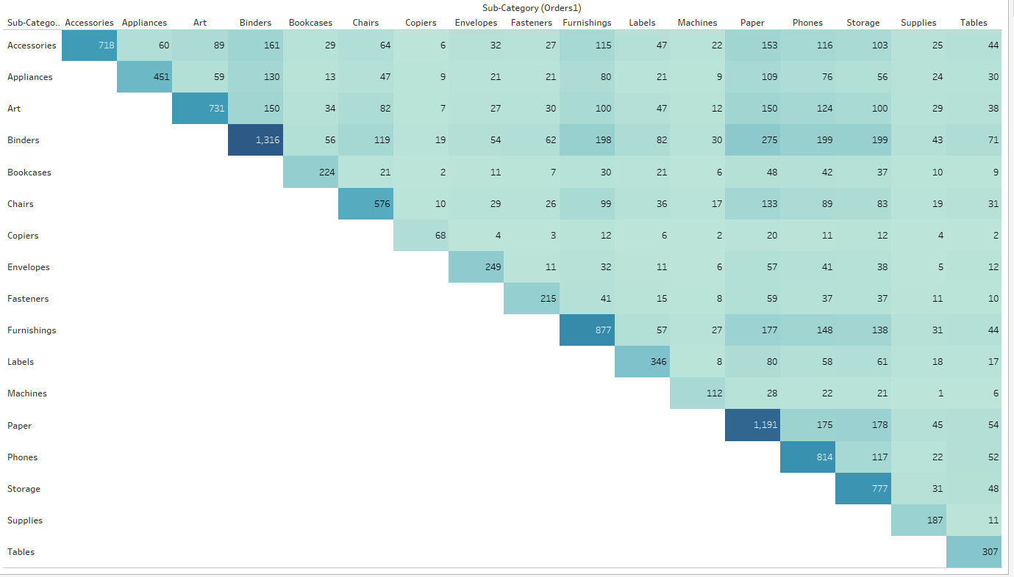

You can see 718 orders contained accessories, 60 orders contained appliances and accessories.

Likewise if you don’t want to see accessories to accessories the go to the data source and change the Sub_category join condition to <.

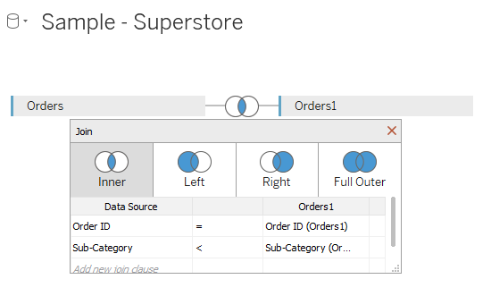

The final output should look like

